External Datasources

Configure BlueDragon

- In BlueDragon Administration, click on data sources.
http://vmsales:8080/bluedragon/admin/index.cfm PW: sysadmin

Example 1
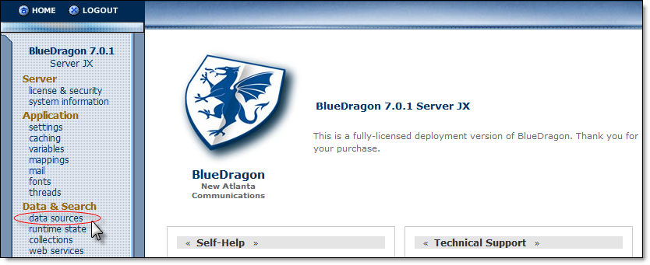

- Click Add Datasource

- Add a Datasource Name. The name entered must be composed of the Company ID (as defined in MasterControl) followed by the word ‘External’. To find the Company ID in MasterControl, click MasterControl Portal > System Settings > System Information. The Company ID will be displayed as part of the Application Variables:

Example 2
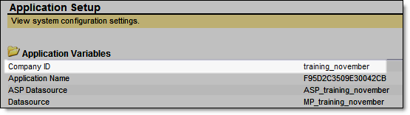
In this case, the Datasource Name would need to be ‘training_novemberExternal’. If multiple Datasources are needed (to connect to multiple databases), additional text may be appended to the end of the Datasource Name.
Examples:
training_novemberExternal_Northwind
training_novemberExternalERP
training_novemberExternalCRM_System

- Once the Datasource Name and the rest of the information (e.g. Database name, server location, credentials, etc.) has been entered, the Datasource can be referenced in MasterControl.

